NEGATIVE INDICES

Revision: Exponents are also called powers or indices.
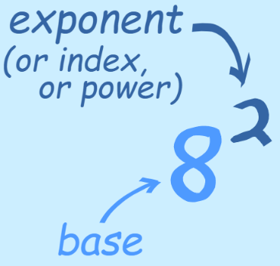
The exponent of a number says how many times to use
the number in a multiplication.
In this example: 8² = 8 × 8 = 64

In words:

8² can be called "8 to the second power", "8 to the power 2" or simply "8 squared"

Negative Exponents

We know that 2³ = 8 and 2⁰ = 1 but what about 2⁻¹ or 2⁻⁶?
Such numbers written in index form using negative indices also have meaning in mathematics.

But what about 8⁻² That exponent is negative ... what does it mean?

Negative? What could be the opposite of multiplying? Dividing!
Dividing is the inverse (opposite) of Multiplying.
A negative exponent means how many times to divide by the number.
Example: 8⁻¹ = 1 ÷ 8 = $\frac{1}{8}$

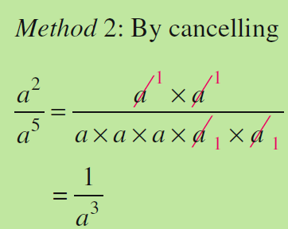
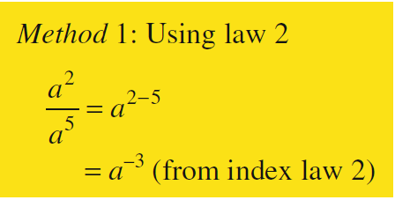
Consider a² ÷ a⁵

Therefore $a^{-3}= \frac{1}{a^{3}}$
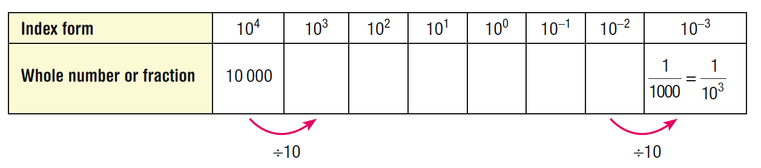
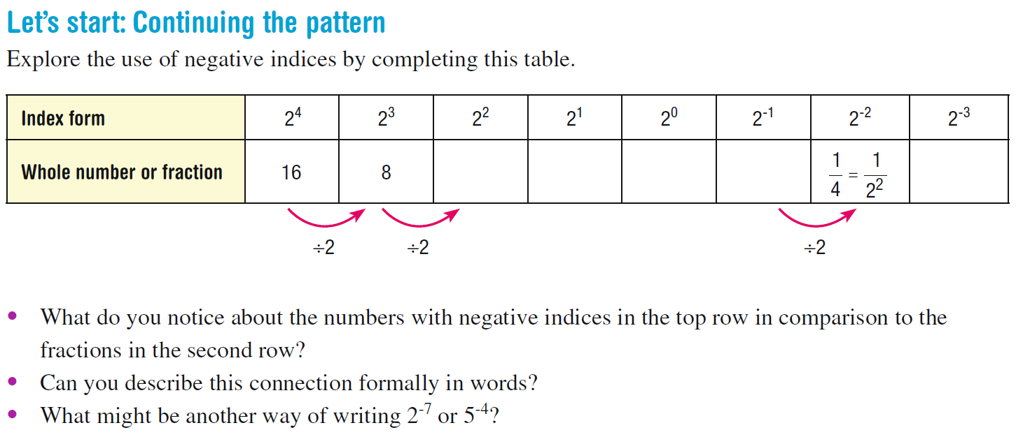
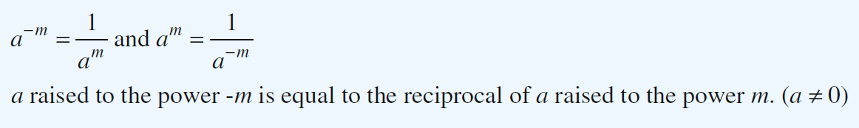

Also Remember: Any number to the power of 1 is just itself $a^{1}=a$

Write the following numbers in index form:

- 2
- 3
- 5
- 17

Example 1: Write 2^{–4} using only positive indices/powers/exponents.

I know that the negative exponent means that the base, the x, belongs on the other side of the fraction line. But there isn't a fraction line! So we need to make one.

Write the following numbers as fractions:

- 2 c) 4

- 3 d) 10
$$x^{-y}= \frac{1}{x^{y}}$$
So 2⁻⁴ = $\frac{2^{-4}}{1}$ = $\frac{1}{2^{4}}$ (index form) =$\frac{1}{16}$ (evaluated)

Flip the fraction upside down (invert or reciprocal) and change the index to a positive

Example 2: Write $\frac{3^{2}}{4^{-3}}$ using only positive exponents.
Only one of the terms has a negative exponent.
This means that you only move one of these terms.
The term with the negative power is underneath; this means that you move it up top, to the other side of the fraction line. There already is a term on top; You will be using exponent rules to combine these two terms. Once you move that denominator up top, you won't have anything left underneath (other than the "understood" 1), so you can drop the denominator.

$\frac{3^{2}}{4^{-3}}$ = $\frac{3^{2} × 4^{3}}{1}=3^{2} ×4^{3} in index form= 9 ×64=576 evaluated$
Example 3: Only the number with the negative power moves and changes power!
Write (2) (3^{–1}) using only positive exponents.
The negative power will become just "+1" once you move the base to the other side of the fraction line. Anything to the power 1 is just itself, so I'll be able to drop this power once I've moved the base. Make sure you understand why the "2" above does not move with the 3: the negative exponent is only on the "3", so only the 3 moves.
(2)(3^{–1}) = $\frac{2}{3^{1 }}$= $\frac{2}{3}$
Write as a fraction then as a decimal
